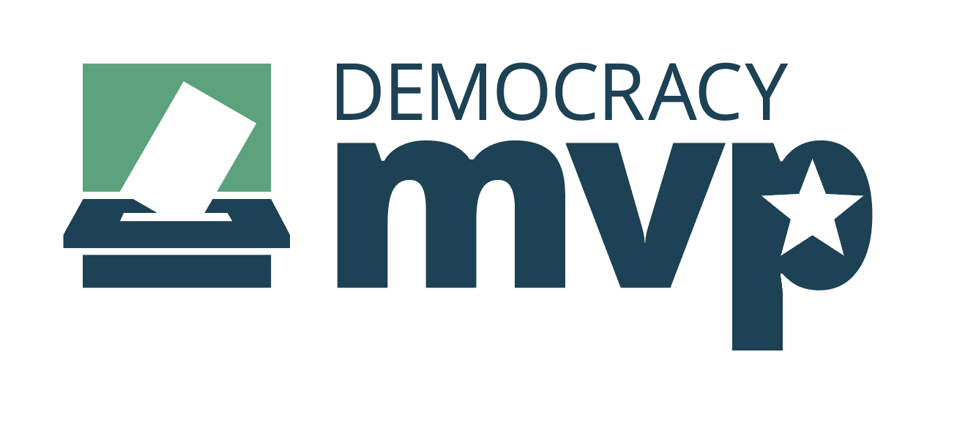

**Election Inspector Recruitment**

**Toolkit and Resource Guide**

*Created by the Michigan Department of State*

*Last updated: September 23, 2022*

# Outline

Michigan needs election inspectors 2

What is Democracy MVP? 3

What you can do 3

Timeline 4

Tracking sign-ups 4

Social media 5

Web graphics 10

Videos 11

Email Outreach 13

Frequently asked questions 14

# Michigan needs election inspectors

Election inspectors are what election workers, or poll workers, are called in Michigan. Election inspectors are hired, paid, and trained local government workers who assist with running local elections. Michigan has 83 counties, 280 cities, and 1,240 townships. During an election, each of these units of government requires a staff of paid and skilled workers, known as election inspectors, to assist voters and help process ballots.

Michigan has a critical need for additional election workers, particularly in advance of mid-term or presidential elections in Michigan, when more workers are required. Administering elections is a team sport, and election inspectors are the Most Valuable Players, helping to ensure local communities in Michigan run smooth, secure and accessible elections.

# What is Democracy MVP?

Democracy MVP is a nonpartisan, statewide election inspector recruitment program run by the Michigan Department of State. Launched in 2020 to address the nationwide poll worker shortage caused by the COVID-19 pandemic, Democracy MVP continues to help connect members of the public interested in serving election clerks and our elections.

The MVP program works with stakeholder partners to recruit among their communities, networks, and supporters. Partners include nonpartisan businesses, nonprofits, and organizations. This coordination helps ensure our great state’s elections are fully staffed, contributing to a smooth, secure, and accessible democratic process.

**Please note** that Democracy MVP does not hire or recruit election observers, including election challengers or poll watchers. Learn more by reviewing our Frequently Asked Questions section at the end of the toolkit.

# What you can do

The Michigan Department of State is looking to partner with stakeholder organizations and individuals to promote the opportunity to serve as a paid election inspector.

Ways you can assist:

1. Raise awareness about the critical need for skilled workers, including individuals with skills in organization, customer service, project management and computer use.
2. Encourage your community, supporters, network, and members of the public to sign up to serve by:
   1. Completing the official election worker interest form and learning about the application, hiring and training process at [Michigan.gov/DemocracyMVP](http://www.Michigan.gov/DemocracyMVP).
   2. Completing an official election inspector application by contacting a local clerk’s office and requesting an application.
3. Raise awareness about the eligibility requirements and responsibilities of serving as an election inspector (See the *Frequently Asked Questions* section for more information).
4. Share information about the opportunity to serve on social media: @DemocracyMVP
   * 1. Use the official hashtag #DemocracyMVP
5. Among hired election inspectors, promote the opportunity to review the Election Inspector Resource Library at [Michigan.gov/DemocracyMVP](http://www.Michigan.gov/DemocracyMVP).

# Timeline

Hiring and training of election inspectors in Michigan typically takes place at least a month prior to Election Day. **Therefore, election inspector recruitment messages are most helpful 4-10 weeks ahead of an election.** However, clerks are always compiling applications for last minute training and hiring and for future elections.

# 

# Tracking sign-ups

If you would like Democracy MVP to track the number of election inspectors referred by your organization, send an email request to Sarah Reinhardt, Director of Special Projects at [ReinhardtS@Michigan.gov](mailto:ReinhardtS@Michigan.gov).

To count the number of referrals from your organization, registrants must enter your organization name in the “additional comments” section of the Democracy MVP Election Inspector Interest Form. Updated sign-up numbers may be provided to your organization upon request.

Please note that Democracy MVP may track the number of individuals completing the interest form but cannot track whether those people have been hired by local clerks.

# Social media

The following pages contain information on Democracy MVP social media, and recommended graphics, posts and promotions for your organization to use for recruitment.

Be sure to tag the Democracy MVP or Michigan Department of State accounts, listed below.

**Facebook**

@DemocracyMVP @MichiganSoS

**Instagram**

@DemocracyMVP @MichiganSoS

**Twitter**

@DemocracyMVP @MichSoS

**Hashtags**

#DemocracyMVP #BeaPollWorker #MichiganNeedsPollWorkers

Graphics on the following pages, and more, are available for [download at this link](https://cms.michigan.gov/sos/-/media/Project/Websites/sos/Resources/Democracy-MVP/Democracy-MVP-Graphics-zip-file.zip?rev=fdbe4bdebdbb4710bcc57832ec7cb488&hash=FBC4F7637B3DC9B3D96DB4433802147D).

 <***Facebook***

<***Instagram***

<***Twitter***

**Text:** Seeking skilled workers to serve as paid election workers for November. Learn more at Michigan.gov/DemocracyMVP

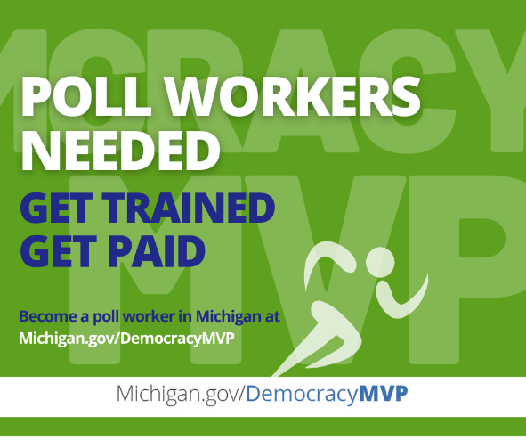***< Facebook***

<***Instagram***

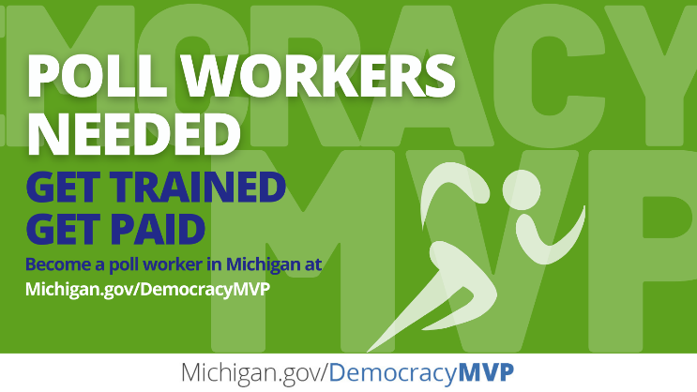***<Twitter***

**Text:** DemocracyMVP is a nonpartisan poll worker recruitment program through the Michigan Department of State. Become a poll worker at Michigan.gov/DemocracyMVP

 ***<Facebook***

 ***< Instagram***

***<Twitter***

**Text:** Get paid to help administer elections in your community. Learn more at Michigan.gov/DemocracyMVP

***< Facebook***

 ***< Instagram***

*** < Twitter***

**Text:** Michigan has a critical need for more paid election workers for November. Learn more about elections and help your country, state and community! Sign up today at Michigan.gov/DemocracyMVP.

# Web graphics

Use these web-ready graphics on your internet / intranet and help motivate your audience to serve as election inspectors. Banner graphics can be linked to [Michigan.gov/DemocracyMVP](http://www.Michigan.gov/DemocracyMVP).

Graphics on the following pages, and more, are available for [download at this link](https://cms.michigan.gov/sos/-/media/Project/Websites/sos/Resources/Democracy-MVP/Democracy-MVP-Graphics-zip-file.zip?rev=fdbe4bdebdbb4710bcc57832ec7cb488&hash=FBC4F7637B3DC9B3D96DB4433802147D).

# Videos

Download and share the below videos to educate and help motivate your audience to serve as election inspectors.

**Democracy is a team sport**

**Link:**[**https://drive.google.com/file/d/1vFKE2RQMepnPIeYZpwbopVa3W8MRARPg/view?usp=sharing**](https://drive.google.com/file/d/1vFKE2RQMepnPIeYZpwbopVa3W8MRARPg/view?usp=sharing)

# [Website Description automatically generated with medium confidence](https://drive.google.com/file/d/1vFKE2RQMepnPIeYZpwbopVa3W8MRARPg/view?usp=sharing)

**Democracy MVP Election Worker Introduction**

**Link:** [**https://www.youtube.com/watch?v=1rGVm5mIAtQ**](https://www.youtube.com/watch?v=1rGVm5mIAtQ)

[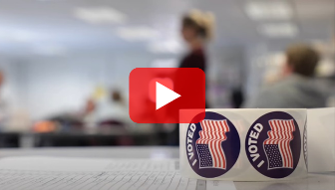](https://www.youtube.com/watch?v=1rGVm5mIAtQ)

**What is an Election Inspector?**

**Link:** [**https://drive.google.com/file/d/1-MOAcGEWKhsk6OAzjZ0dkVEtAUo016cX/view?usp=sharing**](https://drive.google.com/file/d/1-MOAcGEWKhsk6OAzjZ0dkVEtAUo016cX/view?usp=sharing)

](https://drive.google.com/file/d/1-MOAcGEWKhsk6OAzjZ0dkVEtAUo016cX/view?usp=sharing)

**Who Hires Election Workers?**

**Link:** [**https://drive.google.com/file/d/1281-MRoxxy98b36Zkoraqai4_yT6a2I1/view?usp=sharing**](https://drive.google.com/file/d/1281-MRoxxy98b36Zkoraqai4_yT6a2I1/view?usp=sharing)

# [A person standing on a podium Description automatically generated with medium confidence](https://drive.google.com/file/d/1281-MRoxxy98b36Zkoraqai4_yT6a2I1/view?usp=sharing)

**The Difference Between Election Inspectors, Challengers & Watchers?**

**Link:** [**https://drive.google.com/file/d/15SMxL7K-Pkdut260jxO8RKr7OKkVYTOq/view?usp=sharing**](https://drive.google.com/file/d/15SMxL7K-Pkdut260jxO8RKr7OKkVYTOq/view?usp=sharing)

# [A couple of men standing on a podium Description automatically generated with low confidence](https://drive.google.com/file/d/15SMxL7K-Pkdut260jxO8RKr7OKkVYTOq/view?usp=sharing)

# Email Outreach

A sample email outreach letter with accompanying graphics is provided here.

Graphics on the following pages, and more, are available for [download at this link](https://cms.michigan.gov/sos/-/media/Project/Websites/sos/Resources/Democracy-MVP/Democracy-MVP-Graphics-zip-file.zip?rev=fdbe4bdebdbb4710bcc57832ec7cb488&hash=FBC4F7637B3DC9B3D96DB4433802147D).

## 

## 

## Subject: Become a poll worker in Michigan!

# **Body:**

# 

# Dear ________________,

Michigan has a high need for additional election workers to assist in running smooth, secure, and accessible elections in your community.

Elections are a team sport, and election workers are the MVPs. Join the team today! Complete the Michigan election worker interest form and learn more about serving at [Michigan.gov/DemocracyMVP](http://www.Michigan.gov/DemocracyMVP). [***optional language:*** To receive credit for signing up, please input “[*your organization name*]” in the field for organization name when completing the interest form.]

Hired workers will be paid for their time, and fully trained by local or county clerks to run elections in accordance with Michigan election law. Hiring and training will take place throughout the months of September and October, so signup today!

Once you have completed the interest form, share this opportunity with your friends, family, and community on social media. Be sure to tag @DemocracyMVP and *[your organizations social media]* on Facebook, Twitter and Instagram!

Thank you for your participation in this important civic initiative. We are proud of commitment that our organization shows each and every day to making a positive impact in our communities.

Sincerely,

[*your organization name*]

# Frequently asked questions

**How does the Democracy MVP process work?**

Democracy MVP is a nonpartisan election inspector recruitment program of the Michigan Department of State, serving the entire state of Michigan and supporting local clerks. Members of the public who are interested in serving as an election inspector are encouraged to complete the Election Inspector Interest Form at [Michigan.gov/DemocracyMVP](http://www.Michigan.gov/DemocracyMVP).

Please note that completion of the interest form is only the first step in the hiring process and does not guarantee you will be hired to serve as an election inspector.

Once the form is submitted, your information will be provided to local clerks who administer elections and hire election inspectors. A clerk may contact you to request an interview or to complete an official application. You may also contact any local clerk in Michigan directly to ask for an application and to apply directly.

Each of Michigan’s 1,500 clerk offices hire their own election inspectors independently. An election inspector may serve at any office, not just their local clerk’s. However, applying at more than one clerk’s office means you may need to complete separate applications at each office. Please also note that you can only work for one clerk’s office on Election Day. Once hired by a local clerk, you will be required to attend official training provided by clerks on how to administer elections in accordance with Michigan election law.

**Who is qualified to serve as an election inspector?**

To serve as an election inspector in Michigan, you must:

* Be at least 16 years of age
* Affiliate with a political party (per Michigan law, election inspectors may not identify as an independent or as unaffiliated)
* Be a registered voter in the state of Michigan if you are 18+ years of age, or a resident of Michigan if you are 16 or 17 years of age
* Not have a felony or election crime conviction
* Not be an election challenger candidate, member of a candidate's immediate family, or a member of the local board of canvassers

You can check your voter registration status at [Michigan.gov/Vote.](https://mvic.sos.state.mi.us/AVApplication/Index)

**Are election inspectors paid?**

Yes. You will be paid at an hourly rate no lower than the minimum wage. Each clerk’s office sets the rate of pay within their jurisdictions separately.

Please contact a local clerk’s office directly with questions about rate of pay. Clerk information is available at [Michigan.gov/Vote](http://www.Michigan.gov/Vote).

**What are the responsibilities of an election inspector?**

Election inspectors in Michigan help run local elections in compliance with Michigan election law. Election inspectors at a polling place may have different responsibilities, including greeting and checking in voters, issuing ballots to voters, or assisting voters with ballot processing. To inquire about what jobs are available, contact a local election clerk’s office.

**What is the time commitment to serve as an election inspector?**

Once hired, election inspectors are required to attend training to learn how to administer elections in accordance with Michigan Election Law. Trainings are scheduled separately in each Michigan county and, depending on the jurisdiction, trainings may have different durations. Typically, trainings take place in one afternoon or evening. Depending on your assigned role (poll worker, precinct chairperson or absentee ballot processor), you may be asked to attend additional training sessions for your specific responsibilities.

On Election Day, some clerks’ offices require election inspectors to work in shifts throughout the day, while others require election inspectors to work the full day. Polls are open from 7 a.m. to 8 p.m. on Election Day. Typically, election inspectors are required to work from 6 a.m. until after poll close. Hours and shifts may vary depending on the jurisdiction and the assigned role of the inspector.

**What is the difference between an election inspector, an election challenger,**

**and a poll watcher?**

An election inspector is a hired, paid and trained local government worker who assists with running local elections. An election challenger is a non-governmental, credentialed election observer, typically appointed by a political party or interest group to observe elections activities. A poll watcher is a non-governmental volunteer election observer without credentials.

Democracy MVP does not recruit or hire election challengers or poll watchers. Learn more about [the appointment, rights and duties of election challengers and poll watchers](https://mielections.csod.com/clientimg/mielections/MaterialSource/f82645e1-1ee1-461c-ac50-60cb3584f345_9_23_20_Challenger_Booklet.pdf).

For further questions about the Democracy MVP program, please contact Sarah Reinhardt, Director of Special Projects, at [ReinhardtS@Michigan.gov](mailto:ReinhardtS@Michigan.gov).