How do I get to my HFC classes?
- Go to the HFC homepage. (https://www.hfcc.edu/)
- Click the link “STUDENTS” and log in to your student portal.

- Click the link “HFC ONLINE / MOODLE.” This link takes you to your HFC courses.
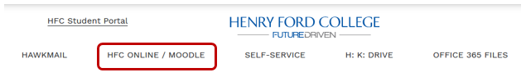

- Next, please click the icon, “HFC Online / Moodle Tutorials Student Course” to self-enroll in this course. This course provides how-to videos to help you use HFC Online/Moodle.

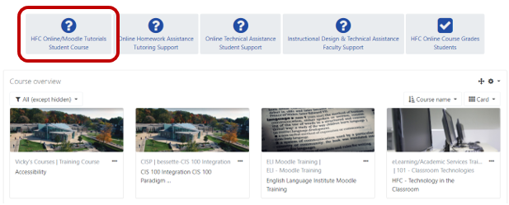
This screen displays your HFC courses.
Click the course name to enter your course.

