
Step-by-Step

Work Study
*No students should start working until all paperwork is turned into Human Resource.
Step One - Application
- For Step One go to careers.hfcc.edu
- Click Student login under the HFC Handshake section.
- Log in or sign up on Handshake. Login info is the same as your self-service.
- Click jobs and select on-campus filter.
- Select a job posting and click apply.
- Download the on-campus application, enable editing, fill out the application, then upload the file to Handshake and click submit application.
*If you do not fill out the application correctly or skip sections, Employers may skip your application.
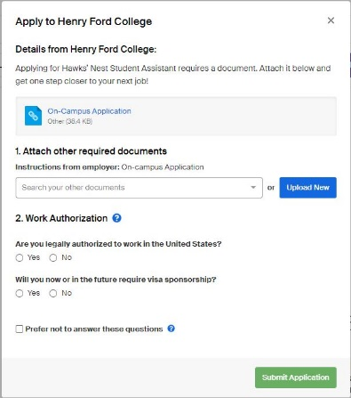



Step Two - Interview
- After you fill out and upload your application keep an eye out for a call or email about an interview.
- After the interview is set and need some help with the interview, click here for tips.
Step Three - Paperwork
- First step is the Hiring Form, the employer will fill this out and you will bring it to the Career Services Office.
- Watch the New Hire Video.
- Take the Quiz.
- Check for email from neoed.gov and fill out attached onboarding paperwork.
- Go to campus safety for student worker ID.

If you need assistance, contact the Career Services Office at 313-845-9618 or by email at careers@hfcc.edu.

